5MP HD IR VF Eyeball Network Camera
IPC3635LB-ADZK-G

Key Features
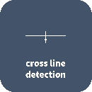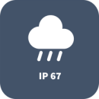

- High quality image with 5MP, 1/2.7"CMOS sensor
- 5MP (2880*1620)@ 25/20fps; 4MP (2560*1440)@ 25/20fps; 3MP (2304*1296)@ 30/25fps;2MP (1920*1080)@30/25fps
- Ultra 265, H.265, H.264, MJPEG
- 120dB true WDR technology enables clear image in strong light scene
- Support 9:16 Corridor Mode
- Built-in Mic
- Smart IR, up to 40m (131ft) IR distance
- Supports 256 G Micro SD card
- IP67 protection
- Support PoE power supply
- 3-Axis

Specifications
 | IPC3635LB-ADZK-G
Camera
Sensor | 1/2.7", 5.0 megapixel, progressive scan, CMOS
Minimum Illumination | Colour: 0.003 lux (F1.6, AGC ON)  0 lux with IR
Day/Night | IR-cut filter with auto switch (ICR)
Shutter | Auto/Manual, 1 ~ 1/100000s
Adjustment angle | Pan: 0° to 360° |  |  | Tilt: 0° to 75° |  |  | Rotate: 0° to 360°
S/N | >56dB
WDR | 120dB
Lens
Lens Type | 2.8 ~ 12mm, AF automatic focusing and motorized zoom lens
Iris | Fixed
Field of View (H) | 108.79°~ 33.23°
Field of View (V) | 56.90°~ 18.33°
Field of View (D) | 112.56°~37.46°
DORI
DORI Distance | Lens (mm) |  | Detect (m) |  | Observe (m) | Recognize (m) |  | Identify (m)
 | 2.8 |  | 63.0 |  | 25.2 | 12.6 |  | 6.3
 | 12 |  | 270.0 |  | 108.0 | 54.0 |  | 27.0
Illuminator
IR Range | Up to 40m (131ft) IR range
Wavelength | 850nm
IR On/Off Control | Auto/Manual
Video
Video Compression | Ultra 265, H.265, H.264, MJPEG
H.264 code profile | Baseline profile, Main profile, High profile
Frame Rate | Main Stream: 5MP (2880*1620), Max 25fps; 4MP (2560*1440), Max 25fps; 3MP (2304*1296), Max 30fps; 1080P (1920*1080), Max 30fps;  Sub Stream: 720P (1280*720), Max 30fps; D1 (720*576), Max 30fps; 640*360,Max 30fps;
Video Bit Rate | 128 Kbps~16 Mbps
U-code | Support
OSD | Up to 4 OSDs
Privacy Mask | Up to 4 areas
ROI | Up to 8 areas
Video stream | Dual streams
Image
White Balance | Auto/Outdoor/Fine Tune/Sodium Lamp/Locked/Auto2
Digital Noise Reduction | 2D/3D DNR
Smart IR | Support
Flip | Normal/Vertical/Horizontal/180°/90°Clockwise/90°Anti-clockwise
Dewarping | N/A
HLC | Support
BLC | Support
Defog | Digital Defog
Events
Basic Detection | Cross line, intrusion(based on human body detection)
 | Motion detection, Ultra motion detection, Tampering alarm, Audio detection
General Function | Watermark, IP Address Filtering, Access Policy, ARP Protection, RTSP Authentication, User Authentication
Audio
Audio Compression |  | G.711U, G.711A
Audio Bitrate |  | 64 Kbps
Two-way Audio |  | N/A
Suppression |  | Support
Sampling Rate |  | 8KHZ
Storage
Edge Storage | Micro SD, up to 256GB
Network Storage | ANR, NAS(NFS)
Network
Protocols | IPv4, IPv6, IGMP, ICMP, ARP, TCP, UDP, DHCP, RTP, RTSP, RTCP, RTMP, DNS, DDNS, NTP, FTP, UPnP, HTTP, HTTPS, SMTP, SSL/TLS, QoS, 802.1x, SNMP
Compatible Integration | ONVIF (Profile S, Profile G, Profile T), API , SDK
User/Host | Up to 32 users. 2 user levels: administrator and common user
Security | Password protection, Strong password, HTTPS encryption, Export operation logs, Basic and digest authentication for RTSP, Digest authentication for HTTP, TLS 1.2, WSSE and digest authentication for ONVIF
Client | EZStation  EZView  EZLive
Web Browser | Plug-in required live view: IE 10 and above, Chrome 45 and above, Firefox 52 and above, Edge 79 and above
 | Plug-in free live view: Chrome 57.0 and above, Firefox 58.0 and above, Edge 16 and above
Interface
Audio I/O | N/A
Alarm I/O | N/A
Serial Port | N/A
Built-in Mic | Support
Built-in Speaker | N/A
WIFI | N/A
Network | 1 RJ45 10M/100M Base-TX Ethernet
Video Output | N/A
Certification
EMC | CE-EMC (EN 55032: 2015+A1:2020,EN 61000-3-3: 2013+A1: 2019,EN IEC 61000-3-2: 2019+A1: 2021,EN 55035: 2017+A11:2020)  FCC (FCC CFR 47 part15 B, ANSI C63.4-2014)
Safety | CE LVD (EN 62368-1:2014+A11:2017)  CB (IEC 62368-1:2014)  UL (UL 62368-1, 2nd Ed., Issue Date: 2014-12-01)
Environment | CE-ROHS (2011/65/EU;(EU)2015/863); WEEE (2012/19/EU); REACH (Regulation (EC) No 1907/2006)
Protection | IP67 (IEC 60529:1989+AMD1:1999+AMD2:2013)
General
Power | DC 12V±25%, PoE (IEEE 802.3af)
 | Power consumption: Max 8.0W
Power Interface | Ø 5.5mm coaxial power plug
Dimensions (Ø x H) | Φ129 x 110mm (Ø5.1” x 4.3”)
Weight | 0.67kg (1.48lb)
Material | Metal
Working Environment | -30°C ~ 60°C (-22°F ~ 140°F), Humidity: ≤95% RH (non-condensing)
Strorage Environment | -30°C ~ 60°C (-22°F ~ 140°F), Humidity: ≤95% RH (non-condensing)
Surge Protection | 6KV
Reset Button | Support

Dimensions
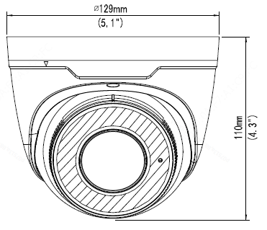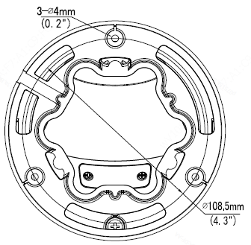

Accessories
TR-JB03-H-IN | TR-JB07/WM03-F-IN | TR-WM03-B-IN | TR-UP06-IN
Junction Box | Wall Mount | Wall Mount | Pole Mount
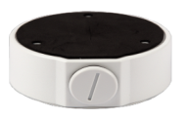 | 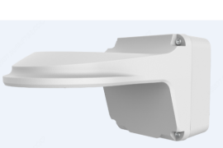 | 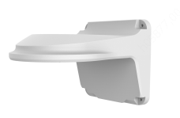 | 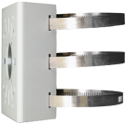
TR-A01-IN | TR-SE24-IN | TR-SE24-A-IN | TR-CM24-IN
Waterproof Joint | Pendant Mount | Pendant Mount | Pendant Mount
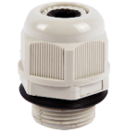

Junction Mount | Pole Mount
TR-JB03-H-IN | TR-JB07/WM03-F-IN(TR-WM03-B-IN)+TR-UP06-IN
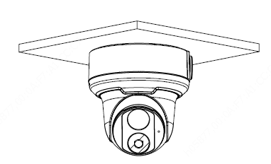 | 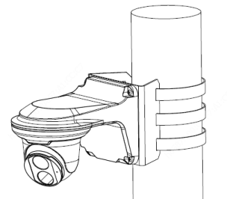
TR-CM24-IN+TR-JB03-H-IN
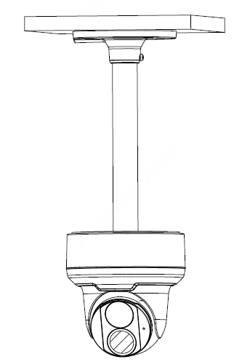

Zhejiang Uniview Technologies Co., Ltd.
Building No.10, Wanlun Science Park, Jiangling Road 88, Binjiang District, Hangzhou, Zhejiang, China (310051)
Email: overseasbusiness@uniview.com; globalsupport@uniview.com
http://www.uniview.com
©2021/2022 Zhejiang Uniview Technologies Co., Ltd. All rights reserved.
*Product specifications and availability are subject to change without notice.

